Maltese health problems

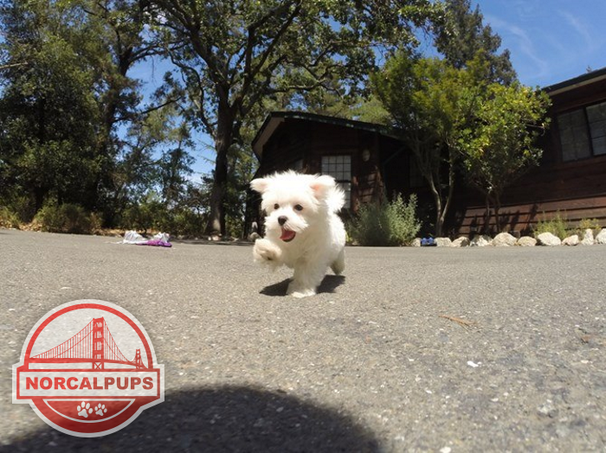The Maltese is a lovely puppy, with a bold personality, which has become very popular. If you want a very small and intelligent dog, to run your home, then this is the perfect breed for you. Maltese puppies are designed to love and to be loved. In general, Maltese is a healthy puppy, but he can develop certain health problems.

Maltese health problems and life expectancy
Maltese dogs are generally healthy and have a lifespan of 12 years or more. However, they can be susceptible to suffer from several health problems.
Maltese puppies, like any other dogs, have the potential to develop genetic health problems. But not all the Maltese health issues are hereditary. If you buy a dog Maltese from a breeder, you should ask for a genetic history to avoid hereditary diseases.
Many Maltese illnesses are related to their size, some are genetic, some acquired. Tiny puppies like Maltese are fragile and they can suffer from different diseases. If you are thinking of getting a Maltese, there are a few Maltese dog health problems that may affect this breed. Not all the Maltese will be affected by these common diseases, but you should know that they are more predisposed to these illnesses.
Eye problems
Maltese are prone to retinal atrophy, a disease that affects vision in dim lighting. The symptoms are bumping into objects or becoming disoriented. Other Maltese puppies health issues related to eyes are conjunctivitis, corneal abrasions, corneal ulcers. Corneal abrasions and ulcers are caused by scratches.
Dental problems
Many small breeds suffer from tooth and gum diseases caused by the overcrowding of teeth in their mouths. They can suffer from tartar and plaque buildup, which untreated can cause periodontal disease. Regular dental care is essential for Maltese puppies.
Hypoglycemia
Hypoglycemia is one of the most common health issues with Maltese dogs. A hypoglycemic dog has an abnormally low blood sugar. Signs of hypoglycemia are: lethargy, weakness, restlessness, and tremors.
Liver shunt
Liver shunt is one of Maltese illnesses, meaning that the dog's circulatory system doesn't develop correctly, affecting the liver. Symptoms include vomiting, seizures, disorientation, pacing and general unthriftiness. The puppies with this condition are usually weaker and smaller in size. This disease can be corrected by surgery.
Luxating patella
Luxating patella is a congenital disease, with the main symptom being an intermittent hopping on the limb when the patella pops out of place. Sometimes this Maltese illness may need surgical correction.
Colitis
Another health problem with teacup Maltese is colitis. Colitis is an inflammation of the large intestine. Symptoms include diarrhea, painful elimination, constipation, vomiting and mucus or blood in the feces.
Tracheal collapse
One of the Maltese breed health problems are collapsed tracheas. This condition occurs also in breeds like: Chihuahuas, Pomeranians, Malteses, and Toy Poodles. Tracheal collapse means that the tracheal rings do not possess normal rigidity resulting in the collapse of the trachea wall as the dog inhales.
How to prevent health problems in Maltese dogs?
A loving Maltese owner should do everything possible to keep his dog healthy by giving him a preventive care, a healthy food and proper exercise. To keep your dog healthy and happy, you should establish a routine, which is very helpful not only for your dog, but also for you.
You should also do a daily health check to be sure that your Maltese has not any illnesses: does your dog look tired, has he any allergies, are there any changes in his appetite, is he losing weight. Any of these problems and many others should be a signal or a warning for Maltese health problems and should send you right to the vet.
Author Bio: This guest post is by Doug of Norcal Pup. I have been a pet owner for my entire life and have enjoyed every minute of it. My family and the animals we care for are my absolute passion in life. I truly enjoy caring for puppies and take pride in doing so daily. I have made it my mission to provide care for the best puppies to the best customers. I enjoy sharing my pet knowledge and experiences in hopes that others will learn from them.

